**DNH QR Code Software**

1. Minimize Not working (Some Windows) (Done By 22Jan ExeVersion(1.0.0.2)

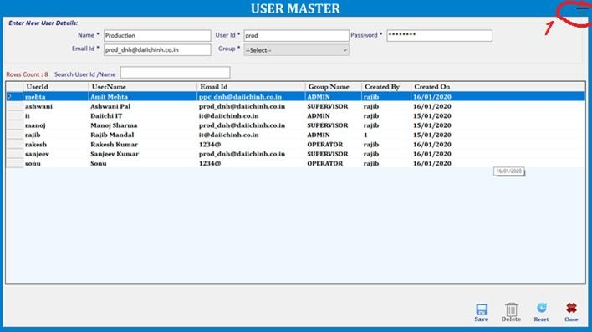

1. It opens in Full Screen, If I want to see other files I Can’t. It should open in stranded size with the view of start

Button. (Done By 22Jan ExeVersion(1.0.0.2)

1. By default it should open Process. (Done By 22Jan ExeVersion(1.0.0.2)
2. With Key picture write change password (Pop Up). For Minimize / Stop also (Done By 22Jan ExeVersion(1.0.0.2 ).

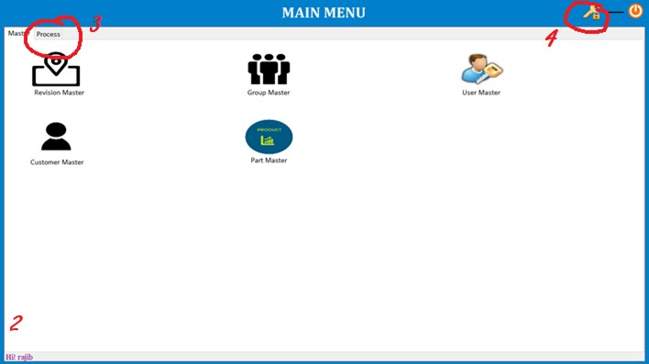

1. All Save Delete Reset Close Buttons should be on upper side with the minimized button

(We can’t do because of default template ).

1. Border line not visible. (Done By 22Jan ExeVersion(1.0.0.2 ).

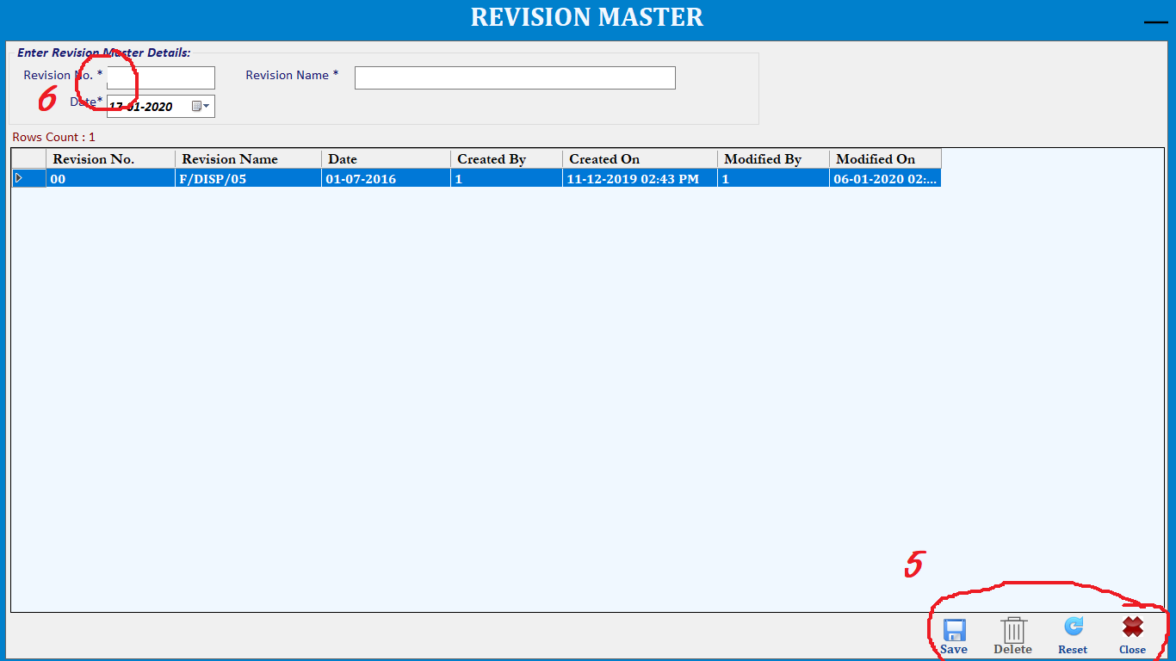

1. Auto Logout on Ideal for more than 5 mins (Will not do(We can do in web app but in window thread will not work while printing).)
2. Unfreeze button no need if supervisor logged in. (Done By 22Jan ExeVersion(1.0.0.2 ).

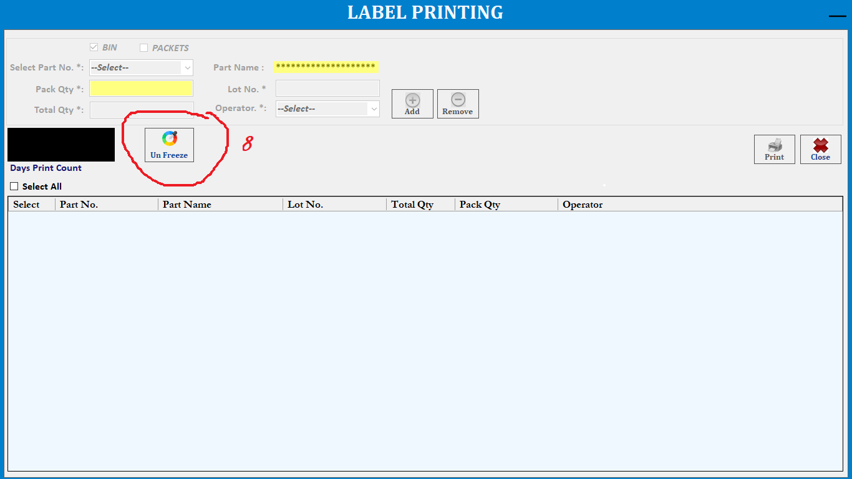

1. Print count not showing in every user (Already showing with diffrent users.)
2. By Default operator name should be the user name. If he wants to select others he can select or he can go head. (Done By 22Jan ExeVersion(1.0.0.2 ).
3. Keep same format(Done By 22Jan ExeVersion(1.0.0.2 ).
4. Please change the Freeze button and the logo its too bad. (Done By 22Jan ExeVersion(1.0.0.2 ).
5. Please put dnh logo and name in every sheet and also provide a **sutable name for the software.**

(Done By 22Jan ExeVersion(1.0.0.2 ).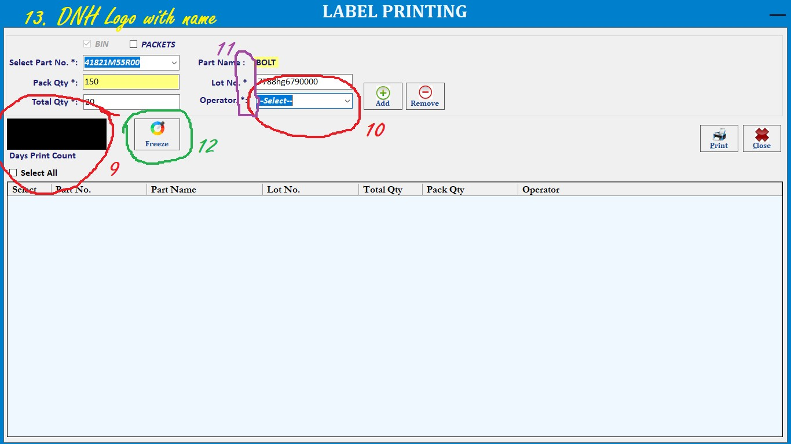

1. After click print it should show us the list of printers, default printer should the same.

No Only one barcode Printer need to set by manually.

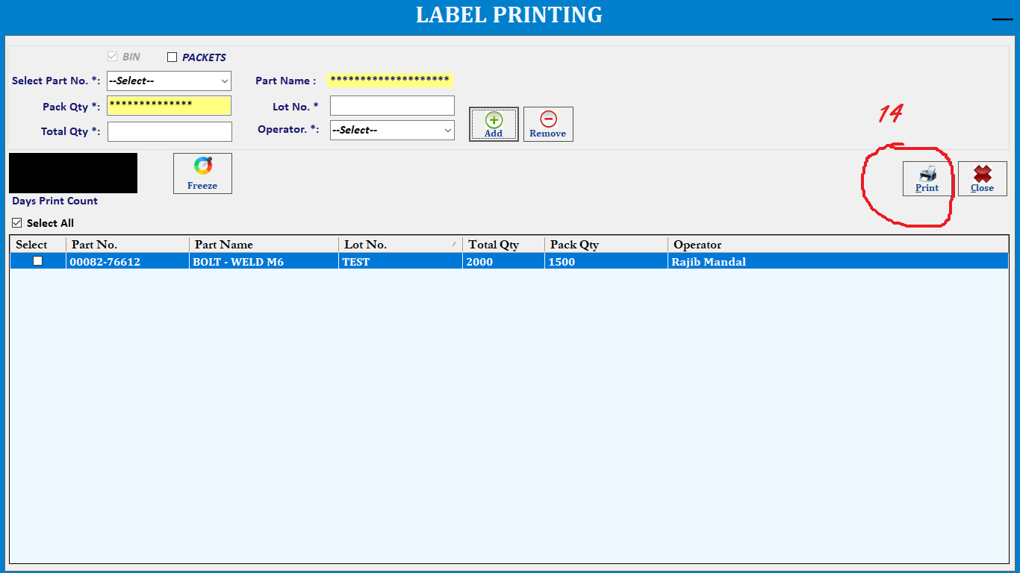

1. Why this short cuts (underlines) not working? Done By 22Jan ExeVersion(1.0.0.2 ).
2. Why this * marks?

Done By 22Jan ExeVersion(1.0.0.2 ).

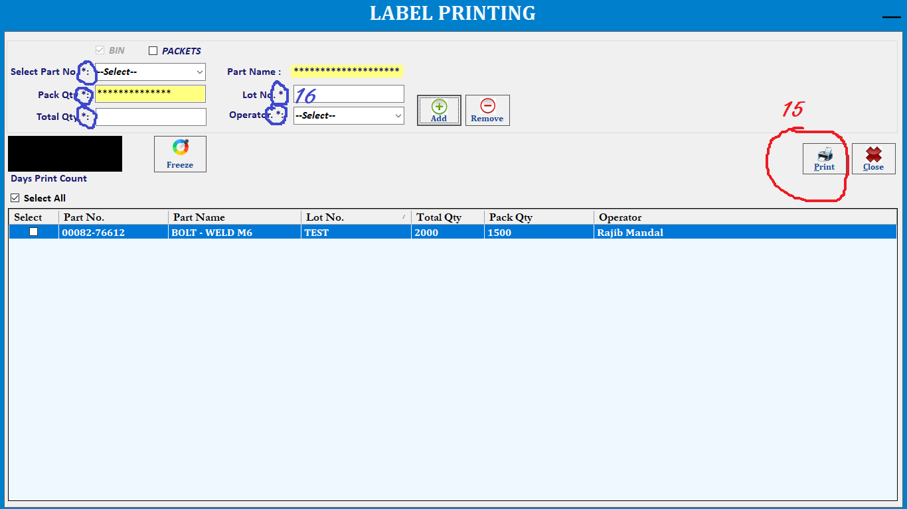

1. Should have shortcuts for other pages. Its annoying to close one page and go to others.

No this is mdi form,it can open one at time.

1. There should sl. Nos only suggestion. No only charactor name search.
2. Name should be only characters not numeric This is the userid by defualt we have added in database.
3. Aliment should be same in every sheet. Done By 22Jan ExeVersion(1.0.0.2 ).
4. Should show full description, adjust accordingly Done By 22Jan ExeVersion(1.0.0.2 ).

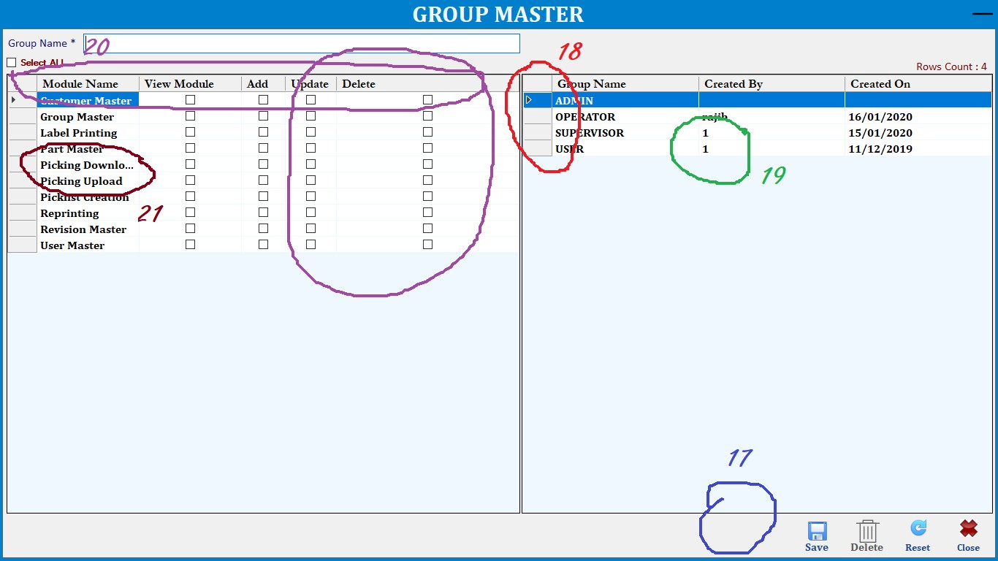

1. What kind of logo is this? Done (Changes done with DNH logo).

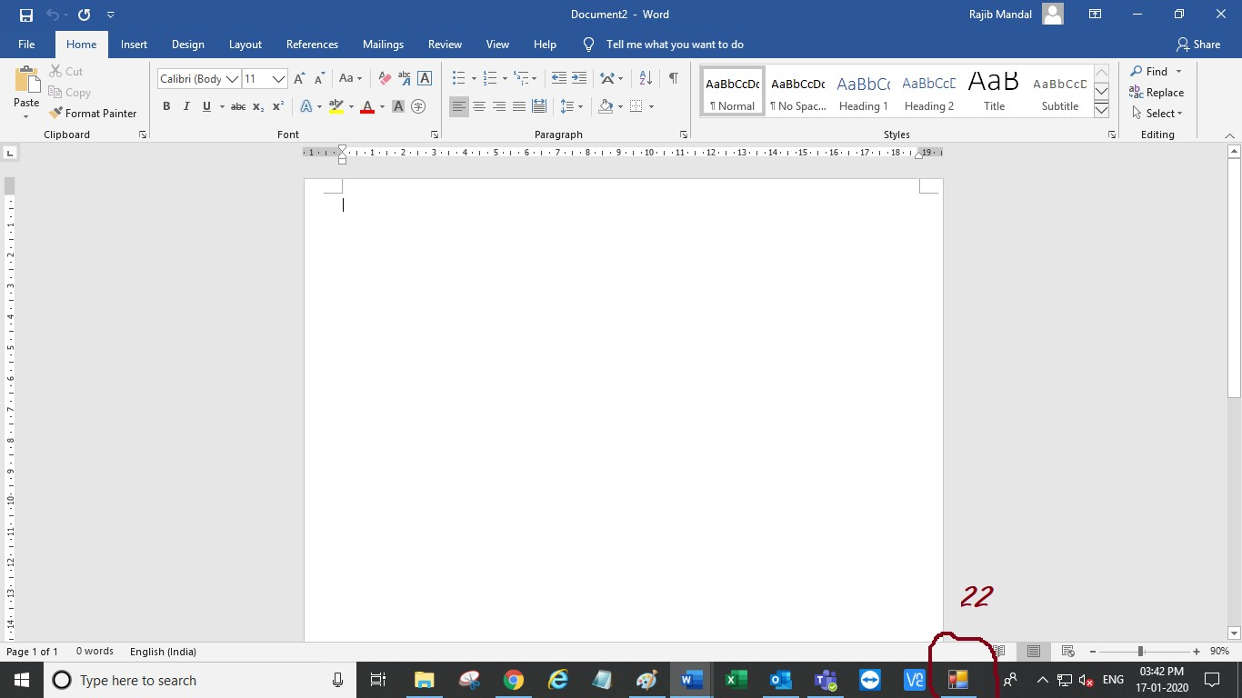

1. Not good Design / Themes with only Basic Logos and Fonts.( No,This is fix template can not be changes.)

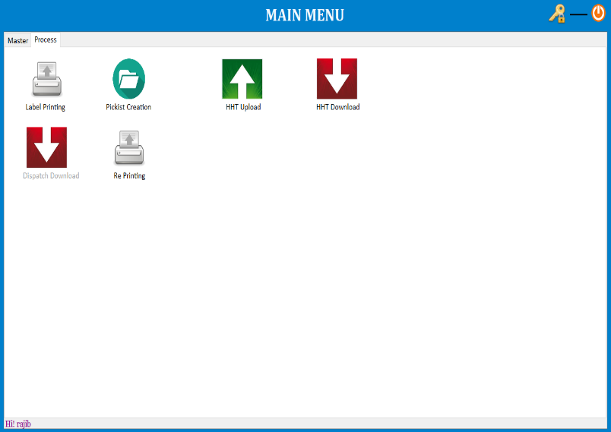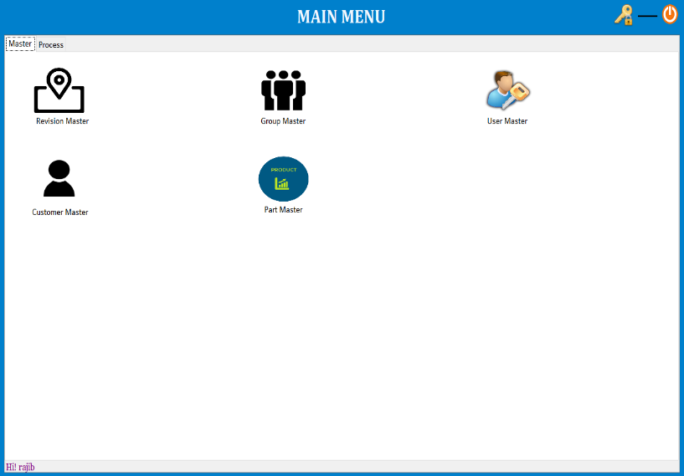

1. Let me know the security parameters. No win form,there is no security parameters.
2. Need the source code, very important. No,Discusse with mayank san.
3. Backup Process and Backup Upload System. will do by DNH
4. In Group Selection it showing twice the options Done By 22Jan ExeVersion(1.0.0.2 ).

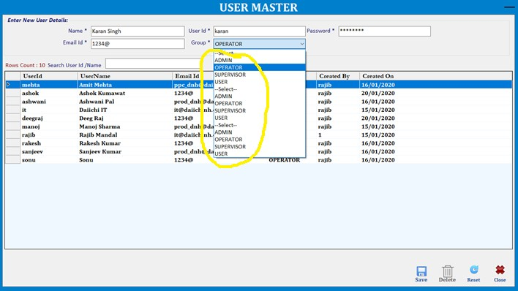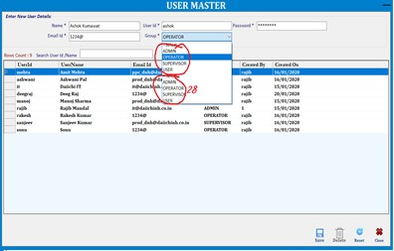

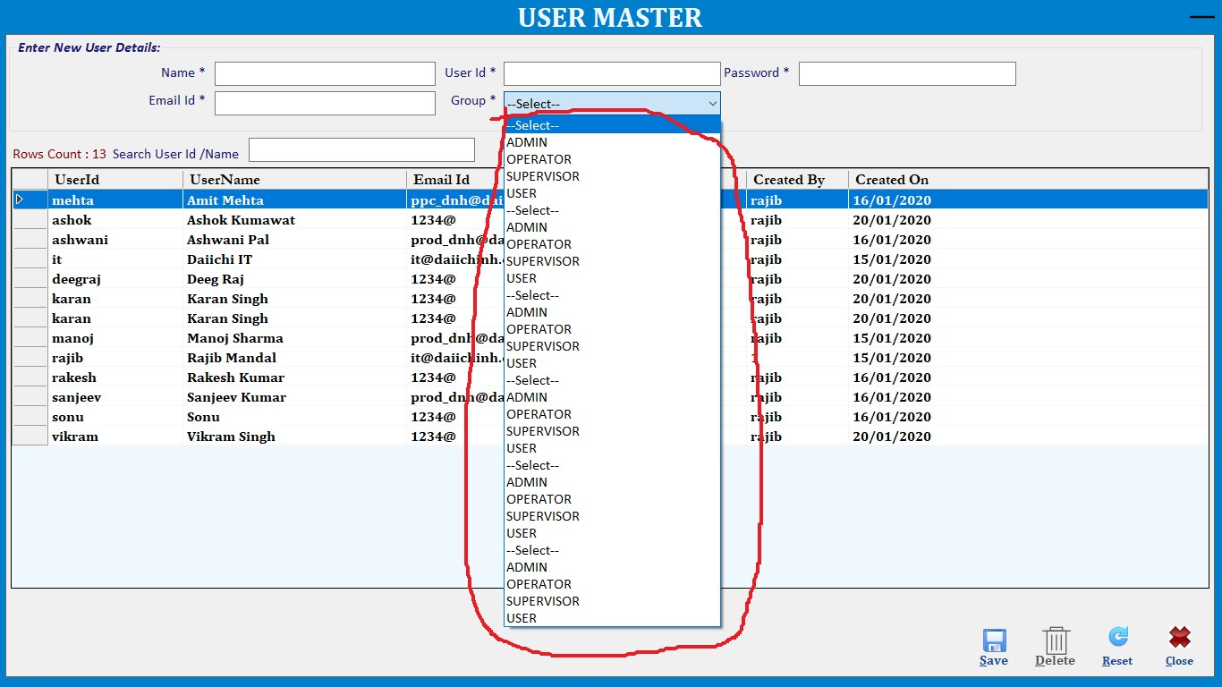

1. Name / User Name duplication should not be there. (Today We have Done(exe version 1.0.0.3)
2. Minimum Password critirea, as of now its accepting anything & password setting option in masters speratly. (Today We have Done(exe version 1.0.0.3)

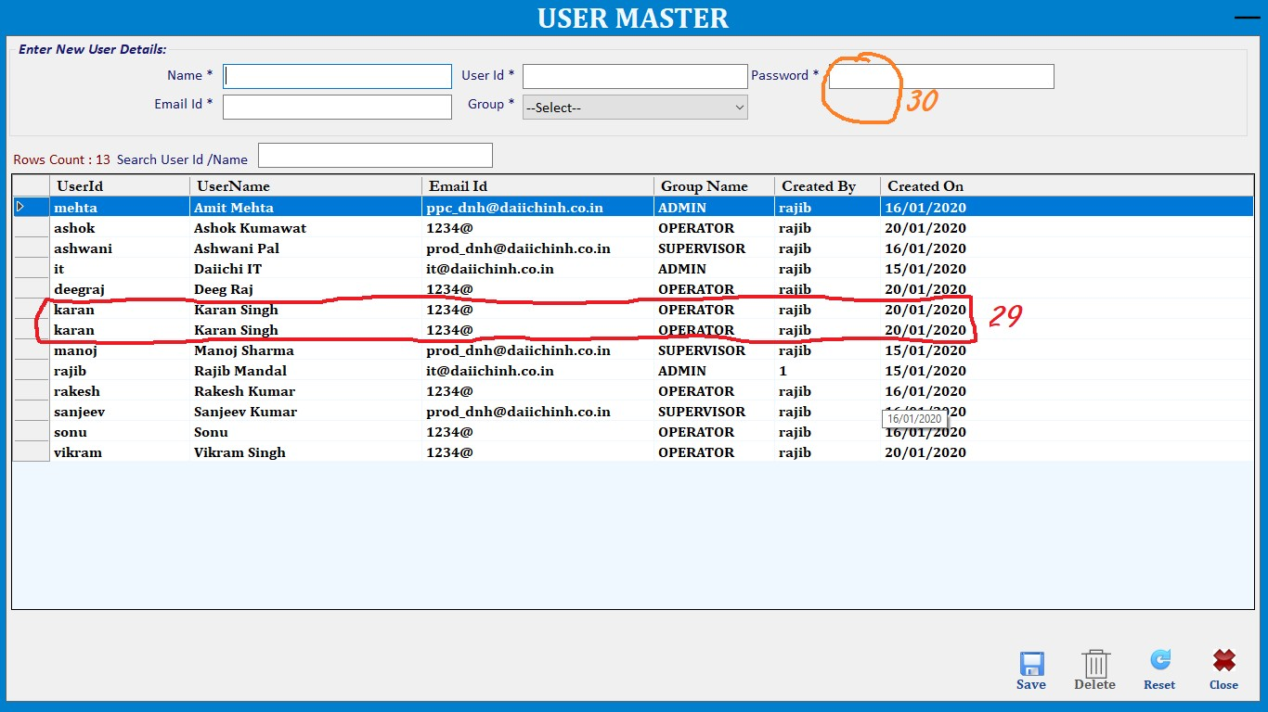

1. User Master add few more fields like – (Make Complete Profile)
   1. His Photo (cannot do because of data storage related issue.)
   2. Employee Code (Today We have Done(exe version 1.0.0.3)
   3. designation

(Today We have Done(exe version 1.0.0.3)

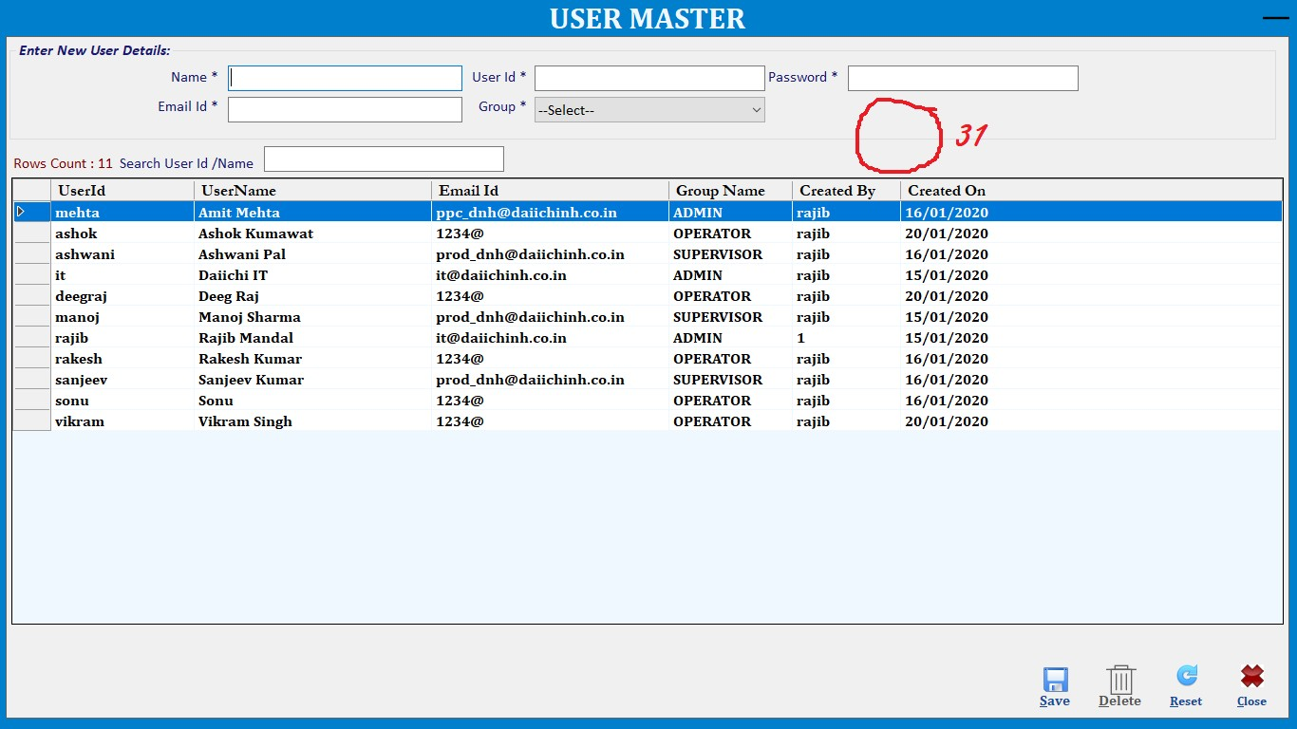

1. Print Overlapping (this happing twice in a day) serial nos are also missing see the yellow mark

(Today We have Done(exe version 1.0.0.3)

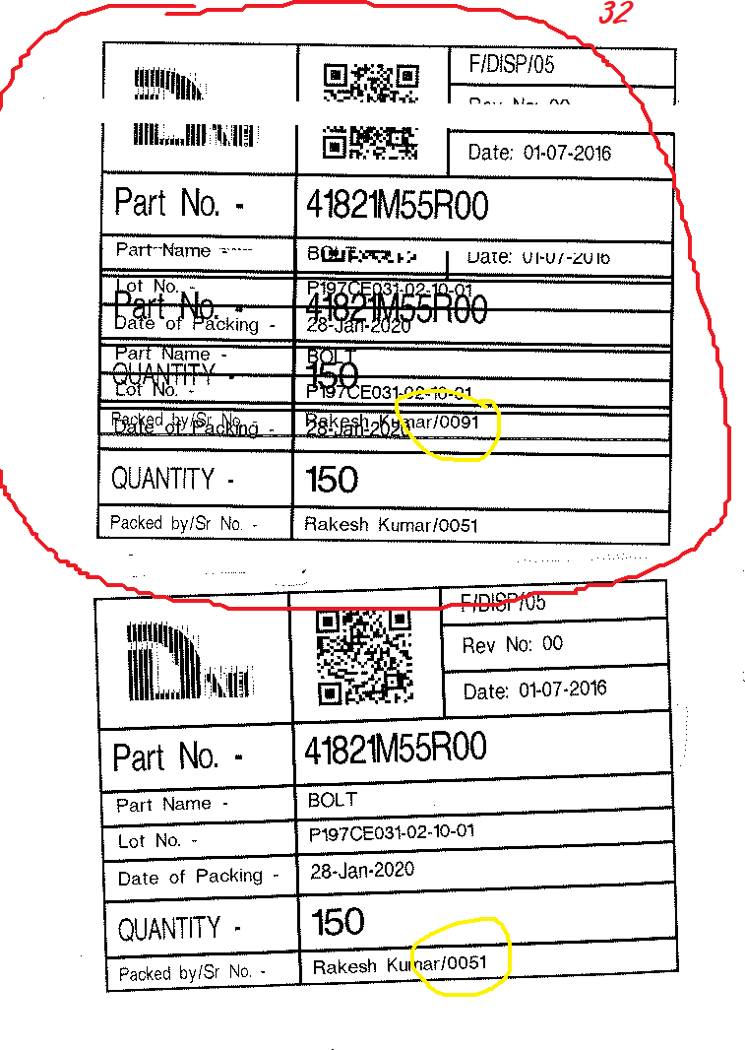

1. In Label Printing we are selecting packets and without packets in same time but the prints are coming double. (Today We have Done(exe version 1.0.0.3)

